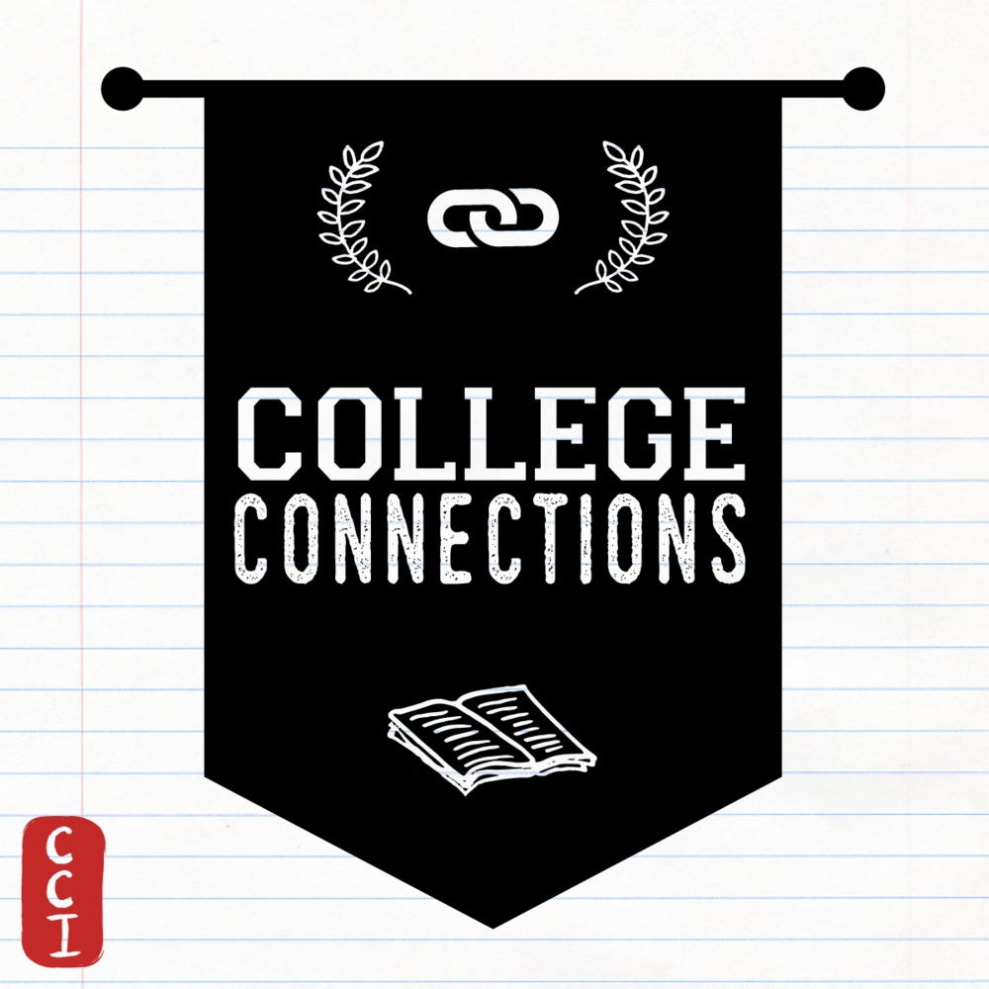

Sign-up
College/University | CCI member’s education received at college/university
Agnes Scott College | Undergraduate
American University | Undergraduate
Bloomsburg University | Undergraduate
Brandeis University | Undergraduate
Butler University | Undergraduate
Canisius College | Undergraduate
Centre College | Undergraduate
Colgate University | University
Connecticut College | Undergraduate
Dartmouth College | Undergraduate
Florida State University | Undergraduate
George Mason University | Undergraduate
George Washington University | Undergraduate
Georgetown | Graduate
Grand Canyon University | Undergraduate
Iowa State University | Undergraduate
Knox College | Undergraduate
Linn Benton | Undergraduate
Michigan State University | Undergraduate
Millikin University | Undergraduate
Montclair State University | Undergraduate
Mount Holyoke College | Undergraduate
New York University Shanghai | Undergraduate
Oregon State University | Undergraduate
Princeton University | Undergraduate
Rutgers University | Undergraduate
San Francisco State University | Undergraduate
Tennessee Technological University | Undergraduate
Texas A&M | Undergraduate
The Ohio State University | Undergraduate
Tufts University | Undergraduate
University of California, Davis | Undergraduate
University of California, San Diego | Graduate
University of North Carolina-Chapel Hill | Undergraduate
University of Florida | Undergraduate
University of Illinois, Urbana Champaign | Undergraduate
University of Maryland, Baltimore County | Undergraduate
University of Maryland, College Park | Undergraduate
University of North Georgia | Undergraduate
University of Oregon | Undergraduate
University of Vermont | Undergraduate
University of Wisconsin, Madison | Undergraduate
Washington University, St. Louis | Undergraduate
West Chester University | Undergraduate
Yale University | Undergraduate & Graduate

